Nem Negash

CMPE 415

Prof. Mohsenin

February 21th 2021

Homework 1 Report

Statement of Project Completion

**What I got to work:**

Problem 1:

1. Implemented truth table as shown in the wave form.

`timescale 1ns / 1ps

module part1();

//inputs

reg a = 1'b0;

reg b = 1'b0;

reg c = 1'b0;

//outputs

reg out_reg = 1'b0;

always @(*)

begin

case ({c,b,a})//case statment using the inputs

3'b000 : out_reg = 1;

3'b001 : out_reg = 1;

3'b100 : out_reg = 0;

3'b101 : out_reg = 0;

3'b110 : out_reg = 1;

3'b111 : out_reg = 0;

endcase

end

//testbench

initial begin

//forloop that checks using all forms of inputs

for(reg[2:0] temp = 3'b000; temp < 8; temp = temp + 1)

begin

a = temp[0];

b = temp[1];

c = temp[2];

#50;

end

end

endmodule

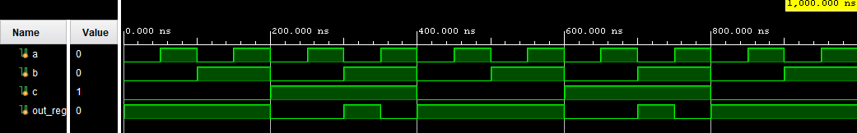

The waveform shows the exact truth tables with the ‘don’t care’ values as ones.

1. Completed the RTL Schematic.

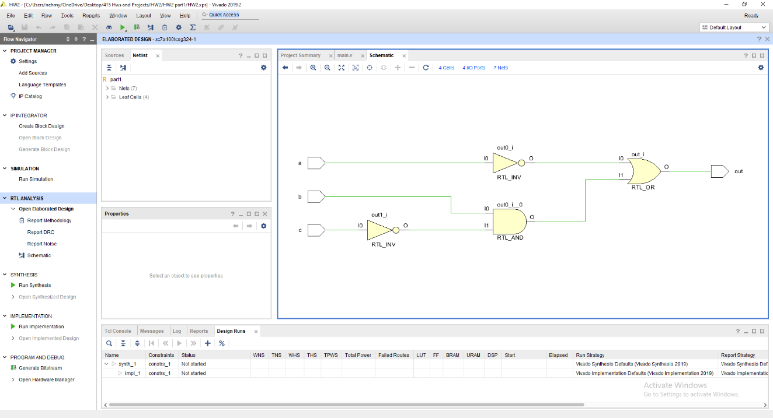

Problem 2:

1. Designed and implemented each ALU operations

`timescale 1ns / 1ps

module part2(

input signed [8:0] A,B, // inputs

input signed [3:0] S,// select

output signed [8:0] Q // output

);

reg signed [8:0] Result;

assign Q = Result; // out

reg [8:0] count = 9'b000000000;//counter for rotate

always @(*)

begin

case(S)

4'b0000: begin // Addition0

Result = A + B ;

end

4'b0001: begin // Subtraction1

Result = A - B ;

end

4'b0010: begin// Multiplication2

Result = A * B;

end

4'b0011: begin// Logical shift right3

Result = B>>A;

end

4'b0100: begin// Rotate left4

Result = {B[9:0]};

for(count = 0; count < A; count = count + 1'b1)

begin

Result = {Result[7:0],Result[8]};

end

end

4'b0101: begin// Logical or 5

Result = A | B;

end

4'b0110: begin// Logical and 6

Result = A & B;

end

4'b0111: begin// Logical nand 7

Result = !(A & B);

end

4'b1000: begin// Logical xnor 8

Result = 9'b111111111 ^ (A ^ B);

end

4'b1001: begin// complement of B 9

Result = (B ^ 9'b111111111) + 1'b1;

end

default: Result = 9'b000000000 ;

endcase

end

endmodule

1. Conducted a test bench for each operation with all possible edge cases.

`timescale 1ns / 1ps

module tb_part2;

reg[8:0] A,B;

reg[3:0] S;

//Output

wire[8:0] Q;

//counter

reg[3:0] i;

part2 test_unit(

.A(A),.B(B), //Inputs

.S(S),//Select

.Q(Q)//output

);

initial begin

// testing all 0s

A = 9'b000000000;

B = 9'b000000000;

S = 4'b0000

#15

for (i=0;i <= 9;i = i+ 1'b1)

begin

S = S + 4'b0001;

#15;

end

//testing all 1s

A = 9'b000000001;

B = 9'b000000001;

S = 4'b0000;

#15

for (i=0;i <= 9;i = i+ 1'b1)

begin

S = S + 4'b0001;

#15;

end;

//testing all positive inputs

A = 9'b000101001;

B = 9'b000100001;

S = 4'b0000;

#15

for (i=0;i <= 9;i = i+ 1'b1)

begin

S = S + 4'b0001;

#15;

end;

//testing all negative inputs

A = 9'b111101111;

B = 9'b111101101;

S = 4'b0000;

#15

for (i=0;i <= 9;i = i+ 1'b1)

begin

S = S + 4'b0001;

#15;

end;

//testing one positive and one negative input

A = 9'b101100001;

B = 9'b000100001;

S = 4'b0000;

#15

for (i=0;i <= 9;i = i+ 1'b1)

begin

S = S + 4'b0001;

#15;

end;

A = 9'b000000000;

B = 9'b000000000;

S = 4'b0000;

end

endmodule

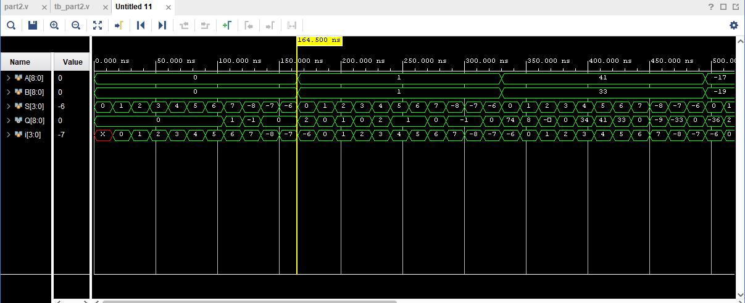

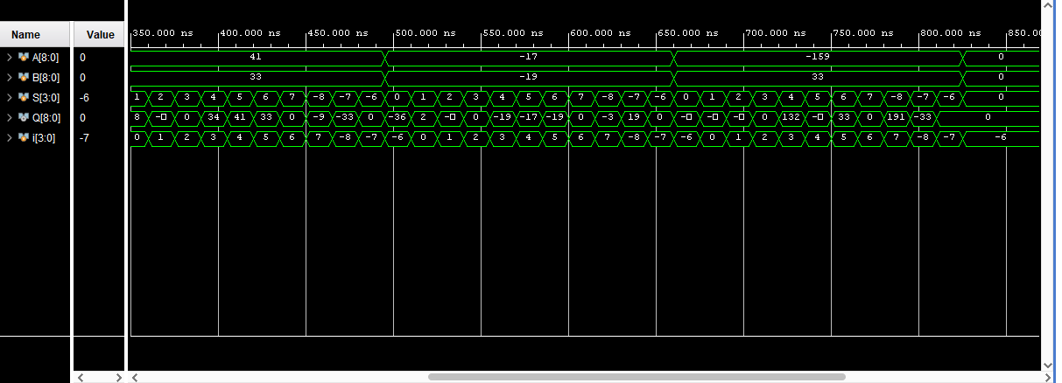

The waveform diagram shows the input values with all edge cases and their output for each operation.

Problem 3:

This part was not completed (Look at the “What I did not get to work” section).

Problem 4:

1. Implement Verilog code to represent a 4-bit counter.

timescale 1ns / 1ps

module part4(input CLK, CLR,ENABLE, UP,LOAD, //single bit inputs

output reg [3:0] Q, //output

input [3:0] V, //load value

output reg RC0); //single bit output

//at clock edge

always @(posedge CLK )

begin

RC0 = 1'b0;//start with RC0 as 0

if (CLR) //if clear is 1

Q = 4'b0000;

else //if clear is 0

if(ENABLE)

if(LOAD)//is load is 1

Q = V;

else//if load is 0

if (UP) //if up is 1

Q = Q + 1'b1;

if(!UP) //if up is 0

Q = Q - 1'b1;

if(Q == 4'b1111 | Q == 4'b0000)//if the output is 15 or 0

RC0 = 1'b1;

end

endmodule

1. Create a test bench for the test bench as specified in the project description

`timescale 1ns / 1ps

module tb_part4;

//variables

reg clk,clr,enable,up,load;

reg[3:0] V;

wire [3:0] Q;

wire rc0;

part4 test_unit(.CLK(clk),.CLR(clr), .UP(up), .Q(Q), .ENABLE(enable), .LOAD(load), .V(V), .RC0(rc0));

//start clock

always #5 clk = (clk ^ 1'b1);

initial begin

//setup

clk = 0;

#5

up = 1;

#10

clr = 1;

//first 10 cycles

#10

clr = 0;

enable = 1;

up = 1;

load = 0;

//hold value for 5 cycles

#100 enable = 0;

//count down for 20 cycles

#50 enable = 1;up = 0;

//clear counter

#195 clr = 1;

//load V value into counter

#5 clr = 0; V = 4'b1100;load = 1; up = 1;

#5 clr = 0; load = 0;

//count up for 11 cycles

#115 enable = 0;

end

endmodule

1. Verify code with wave form diagram

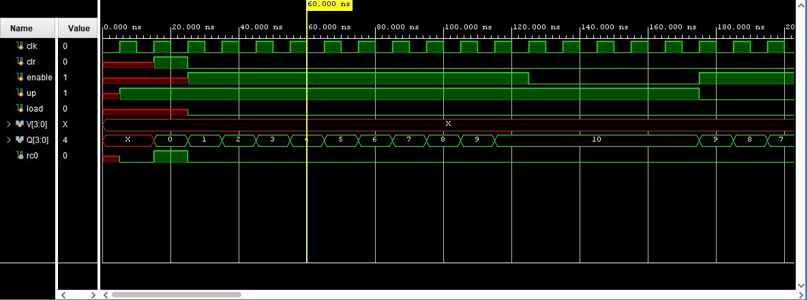

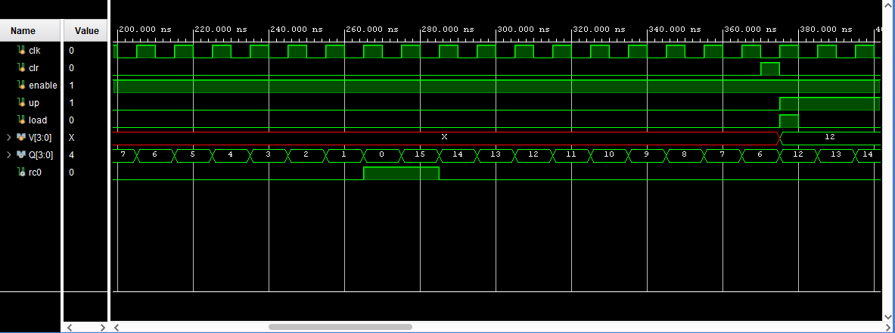

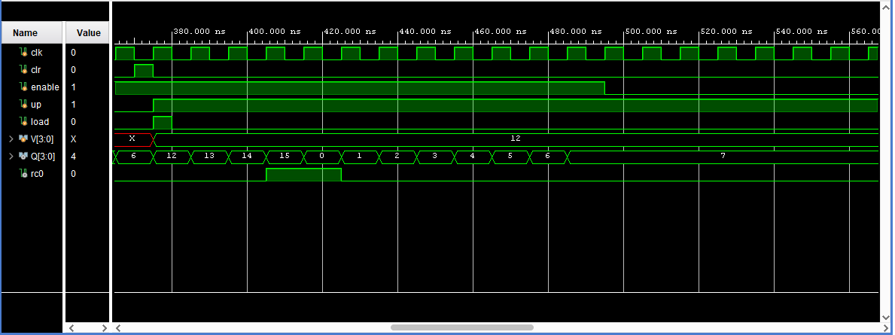

**What I did not get to work:**

Problem 1:

1. I was not able to have a separate test bench file as a simulation source. My test bench is written within the design file

Problem 2:

1. I wasn’t able to have each operation within it’s own module but rather all in one file.

Problem 3:

1. I wasn’t able to figure out how to have the output be a registered output without just assigning the output to a reg variable.

Problem 4:

1. Completed with no exceptions.